Industrial Mini PC
QY-B6000
Desktop CPU Series

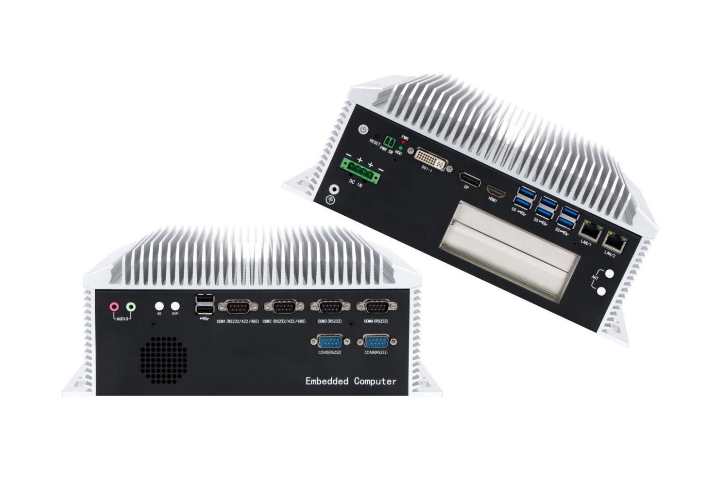

Products Features:
- Industrial-Grade Embedded Fanless Mini PC
- Intel B85 / B365 Chipset
- Intel Celeron, Pentium and Core 4/6/7/8/9th-i3 / i5 / i7 / i9 CPU
- 2*LAN, 8*USB, 6*COM, 1*HDMI, 1*DP, 1*DVI
- 1*Mini PCIE Expansion Slot, Support 4G and WIFI Module
- 1*PCIE 16X or 2*PCI Slots
- DC 9-36V Power Input With Overvoltage Protection
- -30℃~70℃ Temperature Can Keep 24/7 Work Stably
- Anti-Static, Anti-Pulse, Anti-Surge, Anti-Radiation
QY-B6000
1-1.B85 Mother Board Specification:
Model | QY-B6000-2E | QY-B6000-4E | QY-B6000-6E
Chipset | B85
CPU | Celeron G Series  Core 4th-i3 / i5 / i7
Memory | 2*DDR IIII RAM Slots, Up to 16GB
Storage | 1*MSATA SSD Slot  1*M.2 NVME SSD Slot  2*SATA SSD Slots
Display | 1*HDMI: Resolution up to 4096*2304@24Hz  1*DP: Resolution up to 3840*2160@60Hz  1*DVI: Resolution up to 1920*1200@60Hz
Expansion | 1*Mini PCIE Slot, Support 4G and WIFI module  1*PCIE 16X or 2*PCI
Ethernet | 2*Intel i211V LAN Chip | 4*Intel i211V LAN Chip | 2*Intel i211V+4*Intel i210 LAN Chip  (Support POE)
Ethernet | RJ-45 Type (10 / 100 / 1000 Mbps)
USB | 6*USB 3.0 (Type-A)  2*USB 2.0 (Type-A)
COM | 2*RS-232 / 422 / 485 (DB9 Type)  4*RS-232 (DB9 Type) | 4*RS-232 / 422 / 485 (DB9 Type)  4*RS-232 (DB9 Type) | 6*RS-232 / 422 / 485 (DB9 Type)  4*RS-232 (Phoenix Terminal Type)
Audio | 1*Line-In+1*Line-Out

QY-B6000
1-2.B365 Mother Board Specification:
Model | QY-B6000-2E | QY-B6000-4E | QY-B6000-6E
Chipset | B365
CPU | Celeron G Series  Core 6 / 7 / 8 / 9th-i3 / i5 / i7 / i9
Memory | 2*DDR IIII RAM Slot, Up to 64GB
Storage | 1*MSATA SSD Slot  1*M.2 NVME SSD Slot  2*SATA SSD Slots
Display | 1*HDMI: Resolution up to 4096*2304@24Hz  1*DP: Resolution up to 3840*2160@60Hz  1*DVI: Resolution up to 1920*1200@60Hz
Expansion | 1*Mini PCIE Slot, Support 4G and WIFI module  1*PCIE 16X or 2*PCI
Ethernet | 2*Intel i225V LAN Chip | 2*Intel i211V+2*Intel i225V LAN Chip | 4*Intel i210V+2*Intel i225V LAN Chip  (Support POE)
Ethernet | RJ-45 Type (10 / 100 / 1000 / 2500 Mbps)
USB | 6*USB 3.0 (Type-A)  2*USB 2.0 (Type-A)
COM | 2*RS-232/422/485 (DB9 Type)  4*RS-232 (DB9 Type) | 4*RS-232 / 422 / 485 (DB9 Type)  4*RS-232 (DB9 Type) | 6*RS-232/422/485 (DB9 Type)  4*RS-232 (Phoenix Terminal Type)
Audio | 1*Line-In+1*Line-Out

QY-B6000
2.Device Specification:
Watch Dog | Support
Power Input | DC 9-36V With Overvoltage Protection
Power Input | Support Auto-Start
Power Input | 3 Pin Phoenix Terminal Type DC Plug
Working Temperature | -30℃~70℃, Support 24/7 Working
Structure | Fully Enclosed Aluminum Alloy Material
Heat Dissipation | Fanless Design, Conduction Heat Dissipation
Installation | Desktop / Embedded / Wall Mount
Size | 290.5mm*232mm*117.5mm
System | Windows and Linux

QY-B6000
3.Ordering Information:
Model | Chipset | LAN | USB | COM | Display | RAM | SSD | Expansion | Power
QY-B6000-2E | B85 | 2 | 8 | 2*RS-232/422/485  4*RS-232 | 1*HDMI  1*DP  1*VGA | 2*DDR 3  Up to 16GB | 1*M.2 NVME  1*MSATA  2*SATA | 1*Mini PCIE  PCIE or PCI | DC 9-36V
QY-B6000-4E | B85 | 4 | 8 | 4*RS-232/422/485  4*RS-232
QY-B6000-6E | B85 | 6 | 8 | 6*RS-232/422/485  4*RS-232
QY-B6000-2E | B365 | 2 | 8 | 2*RS-232/422/485  4*RS-232 | 1*HDMI  1*DP  1*VGA | 2*DDR 4  Up to 64GB | 1*M.2 NVME  1*MSATA  2*SATA | 1*Mini PCIE  PCIE or PCI | DC 9-36V
QY-B6000-4E | B365 | 4 | 8 | 4*RS-232/422/485  4*RS-232
QY-B6000-6E | B365 | 6 | 8 | 6*RS-232/422/485  4*RS-232

4.System Information:

Chipset | CPU
B85 | Celeron-G Series | Windows XP / 7 / 10 and Linux
B85 | 4th | Windows 7 / 10 and Linux
B365 | 6th / 7th | Windows 7 / 10 and Linux
B365 | 8th / 9th | Windows 10 / 11 and Linux
B365 | Celeron-G series | Windows 10 / 11 and Linux

5.Fittings Information:
QY-B6000
RAM | DDR 3 | 4GB / 8GB
RAM | DDR 4 | 4GB / 8GB / 16GB / 32GB
Storage | M.2 NVME | 128GB / 256GB / 512GB / 1TB / 2TB / 4TB
Storage | MSATA | 64GB / 128GB / 256GB / 512GB / 1TB
Storage | SATA | 120GB / 128GB / 240GB / 256GB / 480GB / 512GB / 960GB / 1TB / 2TB / 4TB
GSM Module | 4G | 4G+GPS
WIFI Module | 7260AN / 7260AC / AX210
GPU | NVIDA T600

6.Package List:

Adapter | 1*12V 10A Adapter
Power Cable | 1*Power Cable
Terminal | 2 Pin Phoenix Terminal for Power

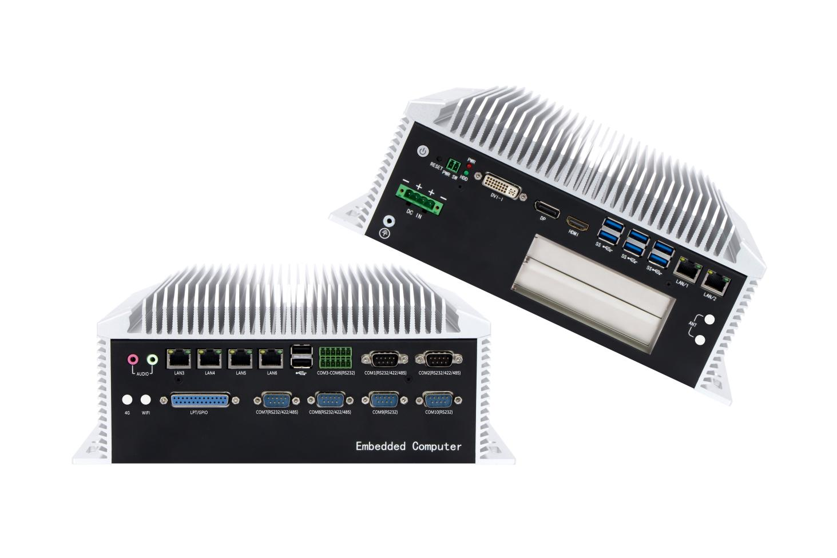
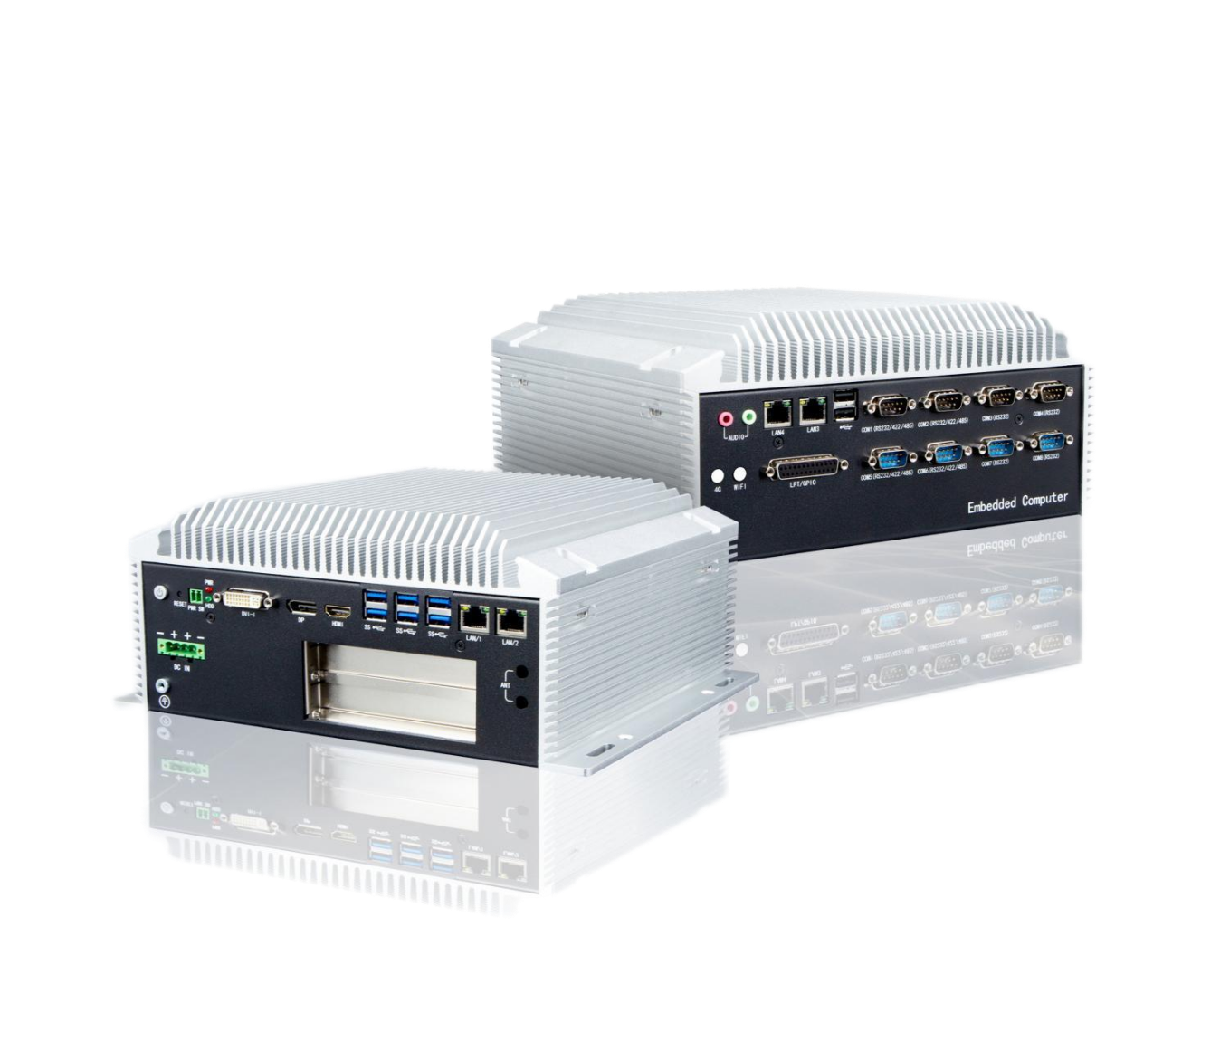
QY-B6000-6E
QY-B6000-4E
7.Picture:
QY-B6000

QY-B6000
8.Dimensions:

